**Practical 1**

**Aim: To design a two-column representation of text-based question using <table> and <p>.**

**Code:**

<!DOCTYPE html>

<html>

<head>

    <meta charset="utf-8">

    <meta name="viewport" content="width=device-width, initial-scale=1">

    <title>First Page</title>

</head>

<body>

    <table width="100%">

        <tr>

            <td width="50%">

                <p>Lorem ipsum dolor sit amet, consetetur sadipscing elitr, sed diam nonumy eirmod tempor invidunt ut labore et dolore magna aliquyam erat, sed diam voluptua. At vero eos et accusam et justo duo dolores et ea rebum. Stet clita kasd gubergren, no sea takimata sanctus est Lorem ipsum dolor sit amet. Lorem ipsum dolor sit amet, consetetur sadipscing elitr, sed diam nonumy eirmod tempor invidunt ut labore et dolore magna aliquyam erat, sed diam voluptua. At vero eos et accusam et justo duo dolores et ea rebum. Stet clita kasd gubergren, no sea takimata sanctus est Lorem ipsum dolor sit amet.</p>

            </td>

            <td width="50%">

                <p align="right">

                    Question: But I must explain to you how all this mistaken idea of denouncing pleasure and praising pain was born

                    <br>

                    <br>

                    A I will give you a complete account of the system, and expound the actual teachings of the great explorer of the truth, the master-builder of human happiness.

                    <br>

                    <br>

                    B But I must explain to you how all this mistaken idea of denouncing pleasure and praising pain was born

                    <br><br>

                    C  I will give you a complete account of the system, and expound the actual teachings of the great explorer of the truth, the master-builder of human happiness.

                    <br><br>

                    D  I will give you a complete account of the system, and expound the actual teachings of the great explorer of the truth, the master-builder of human happiness.

                </p>

            </td>

        </tr>

    </table>

</body>

</html>

**OUTPUT-**

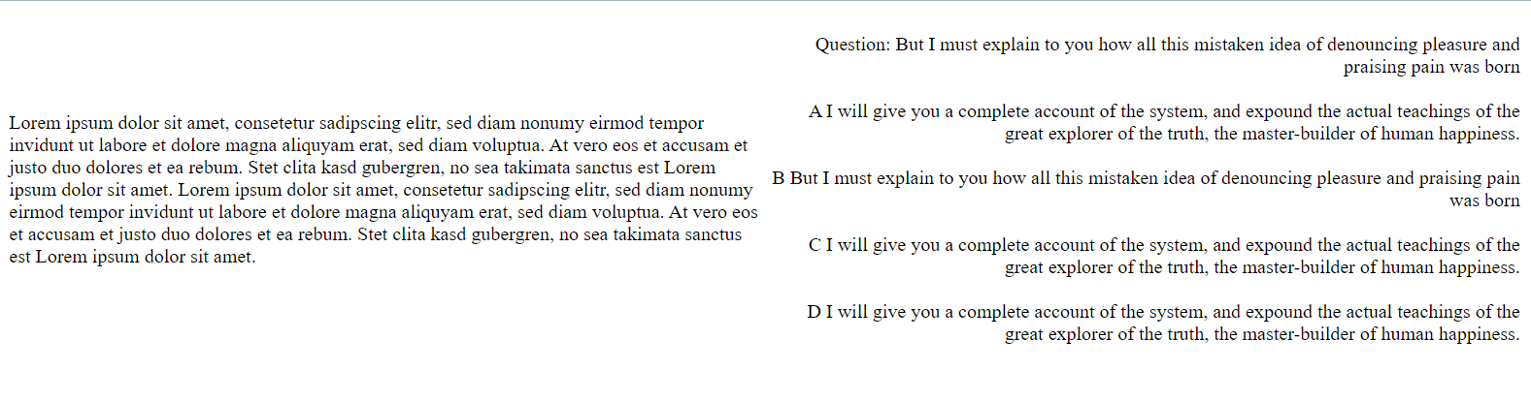

**Aim2: To implement various different input types and <select> tag.**

**Code:**

<!DOCTYPE html>

<html>

<head>

<meta charset="utf-8">

<meta name="viewport" content="width=device-width, initial-scale=1">

<title>Login Page</title>

</head>

<body>

<div align="center">

<form>

<label>Username</label>

<input type="text" name="user" value="Enter Username">

<br><br>

<label>Password</label>

<input type="password" name="pass">

<br><br>

<label>

Enter your current year:

</label>

<br><br>

<input type="radio" name="option1">

<label>First Year</label>

<br><br>

<input type="radio" name="option1">

<label>Second Year</label>

<br><br>

<input type="radio" name="option1">

<label>Third Year</label>

<br><br>

<input type="radio" name="option1">

<label>Fourth Year</label>

<br><br>

<label>Select any 2 of the elective subjects: </label>

<br><br>

<label>Web Development</label>

<input type="checkbox" name="option2">

<br><br>

<label>Python for Data Science</label>

<input type="checkbox" name="option2">

<br><br>

<label>Adavnced Java Programming</label>

<input type="checkbox" name="option3">

<br><br>

<label>Distributed Computing</label>

<input type="checkbox" name="option3">

<br><br>

Tell us something about you:

<br><br>

<textarea rows="10" cols="100">

</textarea>

<br><br>

Date of Birth

<input type="date" name="dob">

<br><br>

Upload your Marksheet:

<input type="file" name="filemarksheet">

<br><br>

Select Your Branch:

<select>

<option value="IT">IT</option>

<option value="EC">EC</option>

<option value="EE">Electrical</option>

<option value="FT">FT</option>

<option value="CP">CP</option>

<option value="CSD">CSD</option>

<option value="Auto">Automobile</option>

<option value="Mech">Mechanical</option>

</select>

<br><br>

<input type="Submit">

</form>

</div>

</body>

</html>

**OUTPUT-**

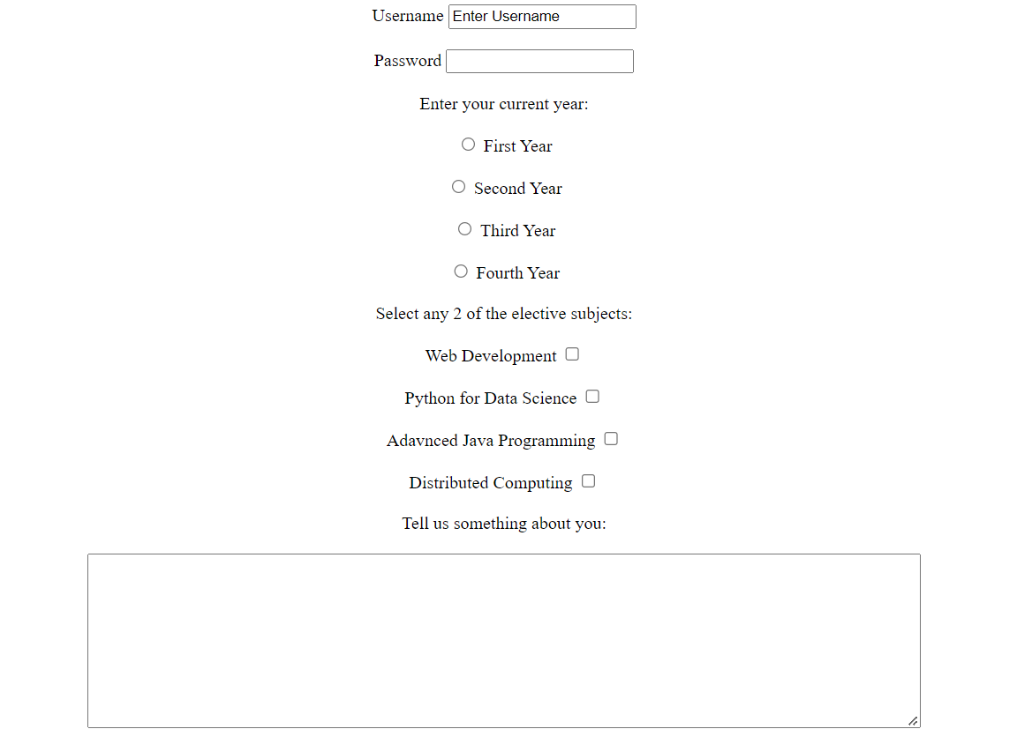

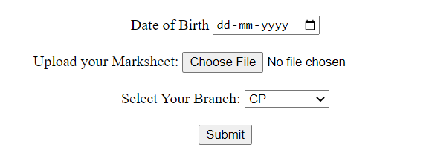

**Practical 2**

**Aim: To learn the use of <a> </a> anchor tag and link different web pages.**

**Code1:**

<!DOCTYPE html>

<html>

<head></head>

<body>

<h1>First page</h1>

<br>

<br>

<a href="second.html">Next</a><br>

To know more<a href="help.html" target="_blank">clickhere</a>

</body>

</html>

**Output:**



**Code:**

<!DOCTYPE html>

<html>

<head>

</head>

<body>

<h1>Second page</h1>

<a href="first.html">Previous</a> <br>

<a href="third.html">Next</a>

</body>

</html>

**Output:**



**Code**:

<!DOCTYPE html>

<html>

<head>

</head>

<body>

<h1>Third page</h1>

<a href="second.html">Previous</a><br>

<a href="fourth.html">Next</a>

</body>

</html>

**Output:**



**Code:**

<!DOCTYPE html>

<html>

<head>

</head>

<body>

<h1>Fourth page</h1>

<a href="third.html">Previous</a><br>

<a href="first.html">Home</a>

</body>

</html>

**Output:**

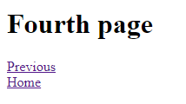

**Code:**

<!DOCTYPE html>

<html>

<head>

</head>

<body>

<h1>Help</h1>

<br>

<br>

</body>

</html> **Output: Help**

**Aim2: To learn the use of meta tag and its attributes.**

**Code**:

<!DOCTYPE html>

<html>

<head>

<meta charset="utf-8">

<meta name="Description" content="This is official website ADIT. It has 8 branches. It is good college">

<meta name="Author" content="Aastha"><!--Author or ownership of content-->

<meta name="Keyword" content="College,Engineering,Gujarat,MBIT,GCET,ADIT,Engineering College,Computer Engineering,CS,Computer Science,FPT,Food processing and Technology"><!--used for displaying if keyword is searched-->

<meta name="viewport" content="width=device-width,minimum-scale=1,initial-scale=1"><!--screen display ratio in different devices-->

<meta http-equiv="refresh" content="5"><!---used for refreshing continously-->

</head>

<body>

<h1>Welcome To A.D. Patel Institute of Technology.</h1>

</body>

</html>

**Output:**



**Practical 3**

**Aim: Creating a class for applying css to table and special effects to <tr> and also applying the box shadow to same.**

**Code:**

<!DOCTYPE html>

<html>

<head>

<meta charset="utf-8">

<meta name="viewport" content="width=device-width, initial-scale=1">

<title>New Page</title>

<style>

.table1{

position: absolute;

top: 200px;

left: 100px;

transform: rotate(-20deg);

width: 200px;

border: 1px solid rgb(159, 243, 255);

border-collapse: collapse;

background-color: rgb(255, 254, 145);

box-shadow: 0 4px 6px 0 rgba(0,0,0,0.4), 0 4px 6px 0 rgba(0,0,0,0.4);

}

.tr1{

height: 20px;

border: 1px solid rgb(159, 243, 255);

border-collapse: collapse;

}

</style>

</head>

<body>

<center>

<table class="table1">

<tr>

<td class="tr1" style="height: 50px;">row1</td>

</tr>

<tr>

<td class="tr1">row2</td>

</tr>

<tr>

<td class="tr1">row3</td>

</tr>

<tr>

<td class="tr1">row4</td>

</tr>

</table>

</center>

</body>

</html>

**OUTPUT-**

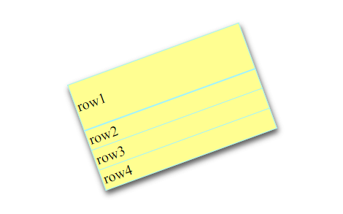

**Practical 4**

**Aim: To study transform and position properties in css.**

**Code:**

<!DOCTYPE html>

<html>

<head>

<meta charset="utf-8">

<meta http-equiv="refresh" content="5">

<meta name="viewport" content="width=device-width,minimum-scale=1,initial-scale=1">

<style>

.tab1{}

.Upside{

transform:rotate(180deg);

}

.move1{

position: absolute;

top:300px;

left:50px;

transform:rotate(-45deg);

border-collapse: collapse;

}

.move2{

position: absolute;

top:300px;

left:50px;

transform:rotate(45deg);

border-collapse: collapse;

}

.withoutpos{

position: absolute;

top:80px;

left:70px;

transform: rotate(45deg);

}

</style>

</head>

<body>

<table class="move1" width="30%" >

<tr style="border-bottom: 1px solid;">

<td align="left">

ADIT

</td>

</tr>

<tr>

<td align="left" class="Upside">

<span>ADIT</span>

</td>

</tr>

</table>

<table class="move2" width="30%" >

<tr style="border-bottom: 1px solid;">

<td align="left">

ADIT

</td>

</tr>

<tr>

<td align="left" class="Upside">

<span>ADIT</span>

</td>

</tr>

</table>

<table class="withoutpos" width="40%">

<tr style="border-bottom: 1px solid;">

<td>

ADIT

</td>

<td class="Upside">

ADIT

</td>

</tr>

<tr>

<td>

<span>ADIT</span>

</td>

<td class="Upside">

ADIT

</td>

</tr>

</table>

</body>

</html>

**Output:**

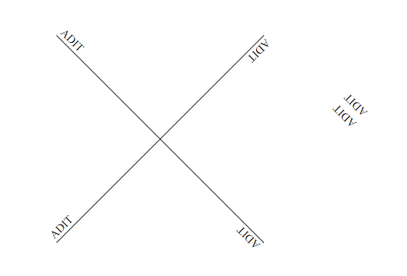

**Practical 5**

**Aim: To study basic overlay effect.**

**Code:**

<!DOCTYPE html>

<html>

<head>

<meta charset="UTF-8">

<meta http-equiv="refresh" content="5">

<meta name="viewport" content="width=device-width, initial-scale=1.0">

<title>Document</title>

<style>

.work{

height:300px;

width:100%;

background-color: rgb(245, 245, 190);

background-image: url("https://images.unsplash.com/photo-1542442828-287217bfb87f?ixlib=rb-4.0.3&ixid=MnwxMjA3fDB8MHxleHBsb3JlLWZlZWR8N3x8fGVufDB8fHx8&auto=format&fit=crop&w=800&q=60");

}

.work1{

position: relative;

top:0px;

left:0px;

height:300px;

width:100%;

text-align:center;

background: linear-gradient(rgba(0,0,0,0.6),rgba(0,0,0,0.1));

}

.work1:hover{

position: relative;

top:0px;

left:0px;

height:300px;

width:100%;

text-align:center;

background: linear-gradient(rgba(0,0,0,0.4),rgba(0,0,0,0));

}

.work2{

position: relative;

top:80%;

left:0px;

height:30px;

width:100%;

text-align:center;

background-color: rgb(224, 224, 62);

}

.hello{

font-size: 15px;

color:white;

}

</style>

</head>

<body>

<div class="work">

<div class="work1">

<span class="hello"> Hello ADIT </span>

</div>

<!-- <div class="work2">

<span class="hello"> Welcome </span>

</div> -->

</div>

</body>

</html>

**Output:**



**Practical 6**

**Aim: To learn to apply media query and its application.**

**Code:**

<!DOCTYPE html>

<html>

<head>

<meta charset="utf-8">

<meta name="viewport" content="width=device-width, initial-scale=1">

<title>New</title>

<style type="text/css">

.div1{

height: 500px;

width: 15%;

background-color: royalblue;

float: right;

}

.div2{

height: 500px;

width: 70%;

background-color: skyblue;

float: right;

}

@media only screen and (max-width: 600px)

{

.div1{

height: 200px;

width: 100%;

background-color: royalblue;

}

.div2{

height: 200px;

width: 100%;

background-color: skyblue;

}

}

</style>

</head>

<body>

<div class="div1"></div>

<div class="div2"></div>

<div class="div1" style="background-color: darkblue;"></div>

</body>

</html>

**Output:**





**Aim: To create a navigation bar that shrinks into a vertical menu using media query.**

**Code:**

<!Doctype html>

<html lang="en">

<head>

<meta charset="utf-8">

<meta http-equiv="X-UA-Compatible" content="IE=edge">

<meta name="viewport" content="width=device-width,minimum-scale=1,initial-scale=1">

<style>

.home{

background-color:rgb(218,8,18);

text-align: center;

line-height: 32px;

font-size:large;

color:rgb(255,255,255);

width:9.09%;

float:right;

height:30px;

}

.home:hover{

background-color:rgb(117, 115, 115);

text-align: center;

font-size:large;

color:rgb(255,255,255);

}

.AboutUs{

background-color: rgba(142, 142, 142,0.5);

line-height: 32px;

text-align: center;

font-size:large;

width:9.09%;

float:right;

height:30px;

}

.AboutUs:hover{

background-color: rgba(117, 115, 115);

text-align: center;

font-size:large;

color:rgb(255,255,255);

}

.Programs{

background-color: rgba(142, 142, 142,0.5);

line-height: 32px;

text-align: center;

font-size:large;

width:9.09%;

float:right;

height:30px;

}

.Programs:hover{

background-color: rgba(117, 115, 115);

text-align: center;

font-size:large;

color:rgb(255,255,255);

}

.Courses{

background-color: rgba(142, 142, 142,0.5);

line-height: 32px;

text-align: center;

font-size:large;

width:9.09%;

float:right;

height:30px;

}

.Courses:hover{

background-color: rgba(117, 115, 115);

text-align: center;

font-size:large;

color:rgb(255,255,255);

}

.Placement{

background-color: rgba(142, 142, 142,0.5);

line-height: 32px;

text-align: center;

font-size:large;

width:9.09%;

float:right;

height:30px;

}

.Placement:hover{

background-color: rgba(117, 115, 115);

text-align: center;

font-size:large;

color:rgb(255,255,255);

}

.Admission{

background-color: rgba(142, 142, 142,0.5);

text-align: center;

font-size:large;

width:9.09%;

float:right;

height:30px;

}

.Admission:hover{

background-color: rgba(117, 115, 115);

text-align: center;

font-size:large;

color:rgb(255,255,255);

}

.StudentCorner{

background-color: rgba(142, 142, 142,0.5);

text-align: center;

font-size:large;

width:9.09%;

float:right;

height:30px;

}

.StudentCorner:hover{

background-color: rgba(117, 115, 115);

text-align: center;

font-size:large;

color:rgb(255,255,255);

}

.Research{

background-color: rgba(142, 142, 142,0.5);

text-align: center;

font-size:large;

width:9.09%;

float:right;

height:30px;

}

.Research:hover{

background-color: rgba(117, 115, 115);

text-align: center;

font-size:large;

color:rgb(255,255,255);

}

.AICTE{

background-color: rgba(142, 142, 142,0.5);

text-align: center;

font-size:large;

width:9.09%;

float:right;

height:30px;

}

.AICTE:hover{

background-color: rgb(82, 79, 79);

text-align: center;

font-size:large;

color:rgb(255,255,255);

}

.Campus{

background-color: rgba(142, 142, 142,0.5);

text-align: center;

font-size:large;

width:9.09%;

float:right;

height:30px;

}

.Campus:hover{

background-color: rgba(117, 115, 115);

text-align: center;

font-size:large;

color:rgb(255,255,255);

}

.Contact{

background-color: rgba(142, 142, 142,0.5);

text-align: center;

font-size:large;

width:9.09%;

float:right;

height:30px;

}

.Contact:hover{

background-color: rgba(117, 115, 115);

text-align: center;

font-size:large;

color:rgb(255,255,255);

}

@media only screen and (max-width:600px)

{

.home{

background-color:rgb(218,8,18);

text-align: center;

font-size:large;

color:rgb(255,255,255);

width:100%;

height:32px;

border-bottom: 1px solid;

}

.AboutUs{

background-color: rgba(142, 142, 142,0.5);

text-align: center;

font-size:large;

width:100%;

height:30px;

border-bottom: 1px solid;

}

.Programs{

background-color: rgba(142, 142, 142,0.5);

text-align: center;

font-size:large;

width:100%;

border-bottom: 1px solid;

height:30px;

}

.Courses{

background-color: rgba(142, 142, 142,0.5);

text-align: center;

font-size:large;

width:100%;

height:30px;

border-bottom: 1px solid;

}

.Placement{

background-color: rgba(142, 142, 142,0.5);

text-align: center;

font-size:large;

width:100%;

height:30px;

border-bottom: 1px solid;

}

.Admission{

background-color: rgba(142, 142, 142,0.5);

text-align: center;

font-size:large;

width:100%;

border-bottom: 1px solid;

height:30px;

}

.StudentCorner{

background-color: rgba(142, 142, 142,0.5);

text-align: center;

font-size:large;

width:100%;

height:30px;

border-bottom: 1px solid;

}

.Research{

background-color: rgba(142, 142, 142,0.5);

text-align: center;

font-size:large;

width:100%;

height:30px;

border-bottom: 1px solid;

}

.AICTE{

background-color: rgba(142, 142, 142,0.5);

text-align: center;

font-size:large;

width:100%;

height:30px;

border-bottom: 1px solid;

}

.Campus{

background-color: rgba(142, 142, 142,0.5);

text-align: center;

font-size:large;

width:100%;

height:30px;

border-bottom: 1px solid;

}

.Contact{

background-color: rgba(142, 142, 142,0.5);

text-align: center;

font-size:large;

width:100%;

height:30px;

border-bottom: 1px solid;

}

}

</style>

</head>

<body>

<div class="home"> Home</div>

<div class="AboutUs"> About Us</div>

<div class="Programs">Programs </div>

<div class="Courses"> Courses</div>

<div class="Placement"> Placement</div>

<div class="Admission"> Admission</div>

<div class="StudentCorner"> Student Corner</div>

<div class="Research"> Research/COE</div>

<div class="AICTE"> AICTE Idea Lab</div>

<div class="Campus"> Campus</div>

<div class="Contact">Contact</div>

<br><br>

</body>

</html>

**Output:**



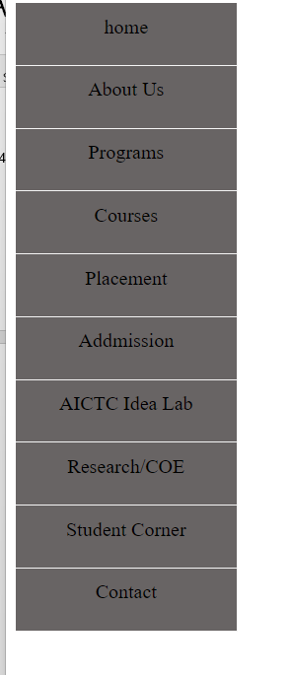

**Practical 7**

**Aim: Creating animation using keyframes and learning the use of animation-duration.**

**Code:**

<!DOCTYPE html>

<html lang="en">

<head>

<meta charset="UTF-8">

<meta http-equiv="X-UA-Compatible" content="IE=edge">

<!-- <meta http-equiv="refresh" content="5"> -->

<meta name="viewport" content="width=device-width, initial-scale=1.0">

<title>Document</title>

<style>

.but{

animation: switch;

animation-duration:4s;

width:90px;

height: 40px;

background:linear-gradient(rgba(33, 223, 175, 0.6),rgba(37, 39, 179, 0.3));

border:none;

border-radius: 5px;

}

@keyframes switch

{

0% {transform: rotate(0deg);}

25% {transform: rotate(20deg);}

/* 45% {transform: rotate(0deg);} */

70% {transform: rotate(-15deg);}

100% {transform: rotate(0deg);}

}

</style>

</head>

<body>

<br><br><br>

<center><button class="but">Hello</button></center>

</body>

</html>

**Output:**

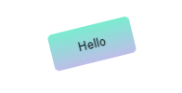

**Part 2: Code:**

<!DOCTYPE html>

<html lang="en">

<head>

<meta charset="UTF-8">

<meta http-equiv="X-UA-Compatible" content="IE=edge">

<meta name="viewport" content="width=device-width, initial-scale=1.0">

<title>Document</title>

<style>

.but{

animation: switch;

animation-duration:2s;

width:400px;

height:40px;

background:linear-gradient(rgba(33, 223, 175, 0.6),rgba(37, 39, 179, 0.3));

border:none;

border-radius: 5px;

}

@keyframes switch{

0% {transform:rotate(360deg)}

100% {transform:rotate(3600deg)}

}

</style>

</head>

<body><br><br><br><br><br><br><br><br>

<center><button class="but">Click</button></center>

</body>

</html>

**Output:**

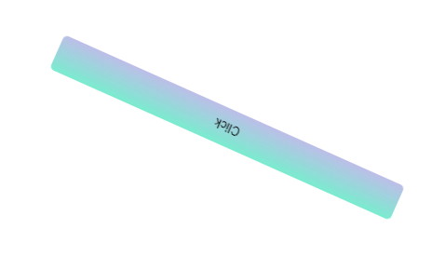

**Practical 8**

**Aim: Creating a color pallet using javascript.**

**Code:**

<!DOCTYPE html>

<html lang="en">

<head>

<meta charset="UTF-8">

<meta http-equiv="X-UA-Compatible" content="IE=edge">

<meta name="viewport" content="width=device-width, initial-scale=1.0">

<title>Layers</title>

<style>

.maintab{

border-collapse: collapse;

}

</style>

</head>

<body>

<table class="maintab" width="40%" height="200px">

<script>

var i,a,b,c;

a=56;

b=11;

c=99;

for(i=0;i<=6;i++)

{

document.write("<tr>");

document.write("<td style=\"background-color:rgb("+a+","+b+","+c+");\"></td>");

document.write("</tr>");

a=a+20;

b=b+20;

c=c+20;

}

</script>

</table>

</body>

</html>

**Output:**

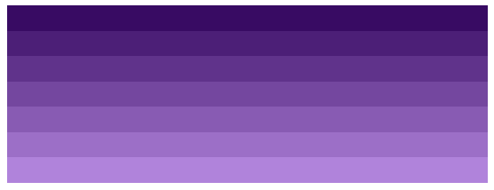

**Practical 9**

**Aim: Creating a simple calculator using JavaScript.**

**Code:c**

<!DOCTYPE html>

<html lang="en">

<head>

<meta charset="UTF-8">

<meta http-equiv="X-UA-Compatible" content="IE=edge">

<meta name="viewport" content="width=device-width, initial-scale=1.0">

<title>Document</title>

<script>

var v1,v2,v3;

function add()

{

v1 = document.getElementById("v1").value;

v2 = document.getElementById("v2").value;

v3 = parseFloat(v1) + parseFloat(v2);

document.getElementById("Ans").innerHTML=v3;

}

function sub()

{

v1 = document.getElementById("v1").value;

v2 = document.getElementById("v2").value;

v3 = parseFloat(v1) - parseFloat(v2);

document.getElementById("Ans").innerHTML=v3;

}

function mul()

{

v1 = document.getElementById("v1").value;

v2 = document.getElementById("v2").value;

v3 = parseFloat(v1) * parseFloat(v2);

document.getElementById("Ans").innerHTML=v3;

}

function div()

{

v1 = document.getElementById("v1").value;

v2 = document.getElementById("v2").value;

if(v2 != 0 )

{

v3 = parseFloat(v1) / parseFloat(v2);

document.getElementById("Ans").innerHTML=v3;

}

else

{

document.getElementById("Ans").innerHTML="Error";

}

}

</script>

</head>

<body>

<label>Value 1:</label>

<input type="number" id="v1"><br><br>

<label>Value 2:</label>

<input type="number" id="v2"><br><br>

Ans:

<span id="Ans">

</span><br><br>

<button onclick="add()">ADD</button>

<button onclick="sub()">SUBTRACT</button>

<button onclick="mul()">MULTIPLY</button>

<button onclick="div()">DIVIDE</button>

</body>

</html>

**Output:**

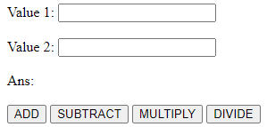

**Aim: Checking the length of phone number using JavaScipt.**

**Code:**

<!DOCTYPE html>

<html lang="en">

<head>

<meta charset="UTF-8">

<meta http-equiv="X-UA-Compatible" content="IE=edge">

<meta name="viewport" content="width=device-width, initial-scale=1.0">

<title>Document</title>

<script>

function Student_Data()

{

var name;

name = document.getElementById("name").value;

phno = document.getElementById("Pno").value;

if(phno.length != 10)

{

document.getElementById("ErrorNo").innerHTML = "Invalid Phone no.";

}

}

</script>

</head>

<body>

name:<input type="text" id="name"><br><br>

EnrollmentNo.:<input type="number" id="eno"><br><br>

branch:<input type="text" id="branch"><br><br>

Phone No.:<input type="number" id="Pno"><br><br>

<p id="ErrorNo"></p>

Email:<input type="email" id="email"><br><br>

<p id="para">

</p>

<button onclick="Student_Data()">Submit Data</button>

</body>

</html>

**Output:**

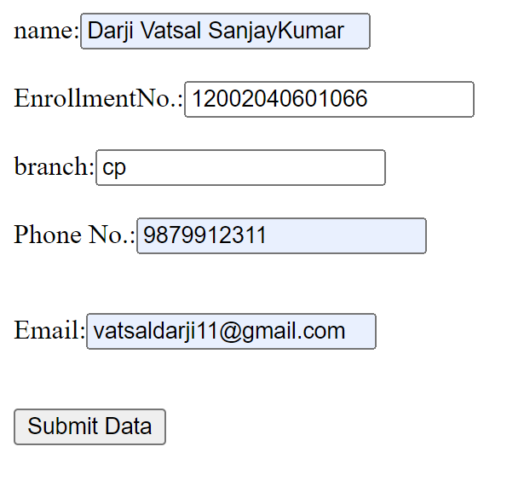

**Practical 10**

**Aim: To take input from user and find the length of it and slice it**

**Code:**

<!DOCTYPE html>

<html lang="en">

<head>

<meta charset="UTF-8">

<meta http-equiv="X-UA-Compatible" content="IE=edge">

<meta name="viewport" content="width=device-width, initial-scale=1.0">

<title>Document</title>

<script>

function func1()

{

var text1 = document.getElementById("name").value;

document.getElementById("data1").innerHTML=text1;

var text2 = text1.length;

document.getElementById("data2").innerHTML=text2;

//charAt

text2 = text1.charAt(2);

document.getElementById("data3").innerHTML=text2;

LocaleCompare

text2="ADIT";

text3 = text1.localeCompare(text2);

document.getElementById("data4").innerHTML=text3;

// Slicing - cutting the string from 3 of length 8

text3 = text1.slice(-3,8);

document.getElementById("data5").innerHTML=text3;

// substring

text3 = text1.substring(3,8);

document.getElementById("data6").innerHTML=text3;

// toUpperCase

text3 = text1.toUpperCase();

document.getElementById("data7").innerHTML=text3;

//replace

text3 = text1.replace("are","and");

document.getElementById("data8").innerHTML=text3;

}

</script>

</head>

<body>

<label>Name:</label>

<input type="text" id="name"><br><br>

<!-- <input type="text" id="email"> -->

<input type="submit" value="Submit Data" onclick="func1()">

<p id="data"></p>

<p id="data1"></p>

<p id="data2"></p>

<p id="data3"></p>

<p id="data4"></p>

<p id="data5"></p>

<p id="data6"></p>

<p id="data7"></p>

</body>

</html>

**Output:**

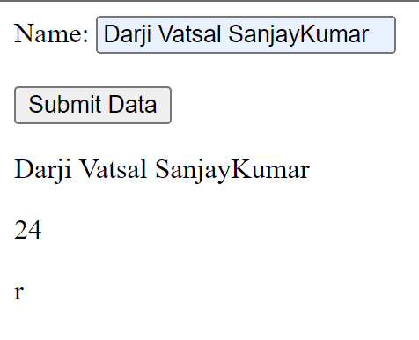

**Practical 11**

**Aim: To set a clock using JavaScript having start and stop buttons.**

**Code:**

<!DOCTYPE html>

<html lang="en">

<head>

<meta charset="UTF-8">

<meta http-equiv="X-UA-Compatible" content="IE=edge">

<meta name="viewport" content="width=device-width, initial-scale=1.0">

<title>Document</title>

<script>

var hour=0;

var min=0;

var sec=0;

function clock()

{

sec = sec + 1;

if(sec<60)

{

document.getElementById("clk").innerHTML=hour+":"+min+":"+sec;

}

else

{

min = min+1;

sec = 0;

if(min<60)

{

document.getElementById("clk").innerHTML = hour+":"+min+":"+sec;

}

else

{

hour = hour + 1;

min = 0;

document.getElementById("clk").innerHTML = hour+":"+min+":"+sec;

}

//windows.location.href do for some min and used to switch to new page.

}

}

</script>

</head>

<body>

<script>

function start()

{

const clock1 = setInterval(clock,1000);

}

function stop()

{

// document.getElementById("clk").innerHTML="0:0:0";

clearInterval(clock1);

}

</script>

<p id="clk">

</p>

<button onclick=start()>start</button>

<button onclick=stop()>stop</button>

</body>

</html>

**Output:**

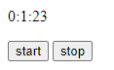

**Practical 12**

**Aim: Write a Sample Program in PHP**

**Code:**

<! DOCTYPE html>

<html>

<body>

<?php

echo " <h1> <center> Hello, Welcome to PHP Program </h1> </center></br>";

echo "Computer Engineering, ADI"

?>

</body>

</html>

OUTPUT-



**Aim: To store values in a variable and also print sum of 2 numbers.**

**Code:**

<! DOCTYPE html>

<html>

<body>

<?php

$a = "ADIT";

$b ='c';

$x = 14;

$y = 102.55;

$z = $x+$y;

echo "Hello " .$a. " Welcome <br>";

echo "Total is ". $z;

?>

</body>

</html>

OUTPUT-

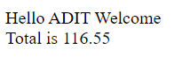

**Aim: Checking session variables that were set on previous page.**

**Code:**

<?php

session_start();

?>

<!DOCTYPE html>

<html>

<body>

<?php

$_SESSION["col"] = "ADIT";

$_SESSION["branch"] = "CP";

?>

//Checking session variables<br>

<?php

// Echo session variables that were set on previous page

echo "Welcome, your college is " . $_SESSION["col"] . ".<br>";

echo "Your Branch is " . $_SESSION["branch"] . ".";

?>

</body>

</html>

**OUTPUT-**

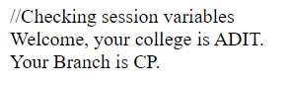

**Aim: Printing a variable and converting it to upper case in php.**

**Code:**

<!DOCTYPE html>

<html lang="en">

<head>

<meta charset="UTF-8">

<meta http-equiv="X-UA-Compatible" content="IE=edge">

<meta name="viewport" content="width=device-width, initial-scale=1.0">

<title>Document</title>

</head>

<body>

<?php

$x = "adit";

echo strtoupper($x);

?>

</body>

</html>

**Output:**

